**1.Demonstrate how to set up Postman.**

Postman is a GUI that aids in the development of APIs by making it easy to test requests and their responses in an organized way. Everything you can do in Postman you can also do through the command line, but Postman makes the process quicker and easier by providing a clean interface and powerful set of tools.

-Create a workspace:

Click on workspaces->Select blank workspace->Name the workpace->Click on next->Select the type of workspace

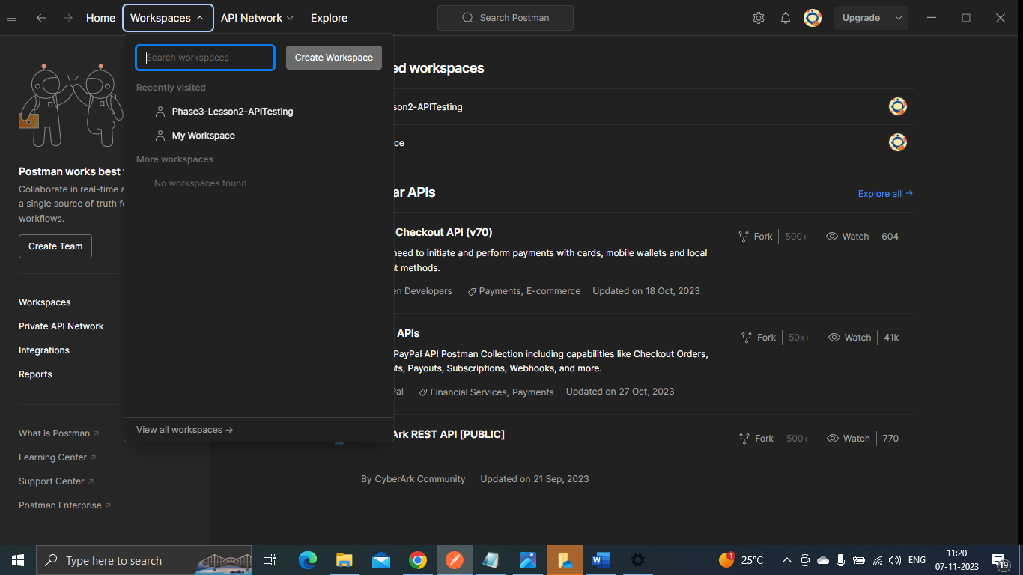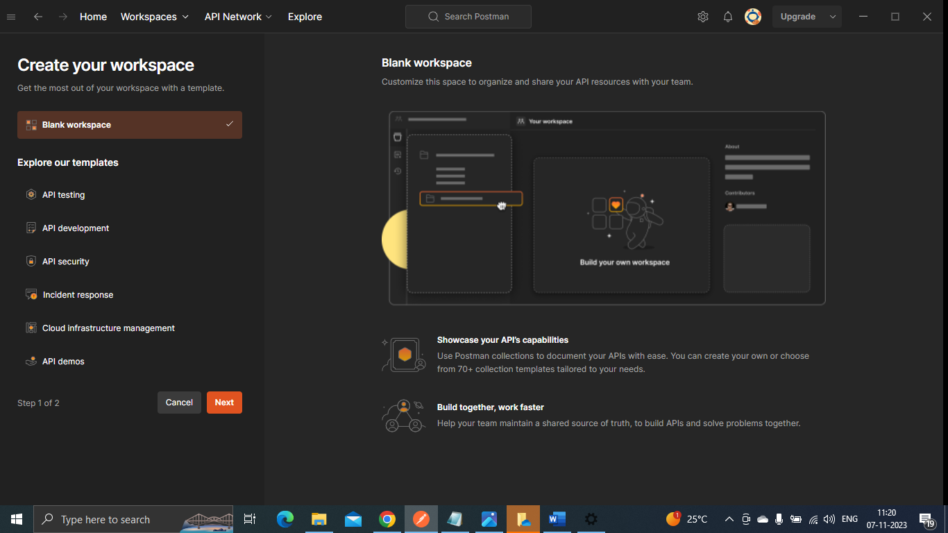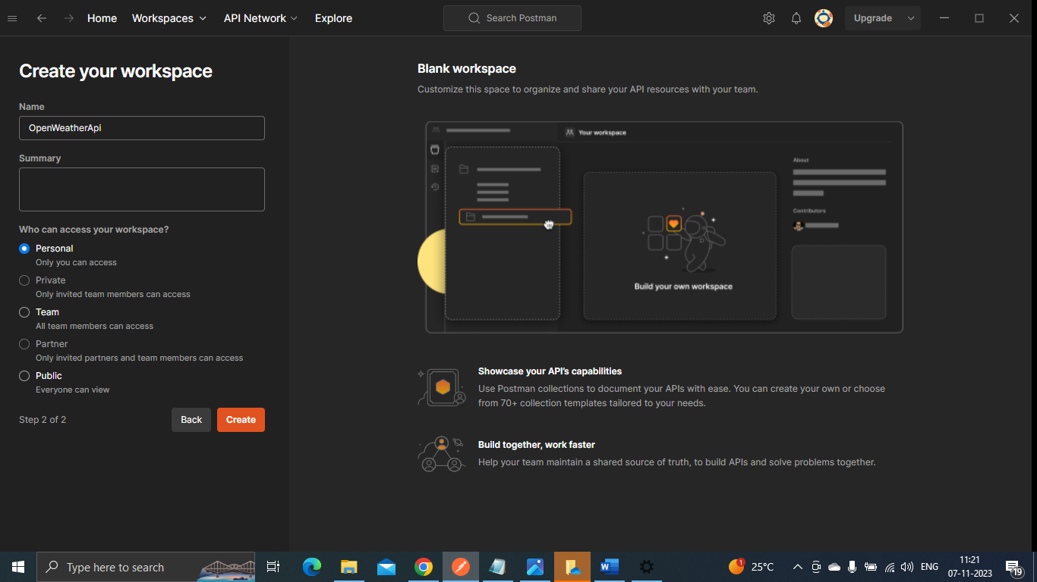

-We need to add collections->In collections Add a request

